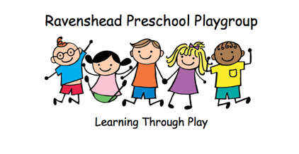
Uniform Order Form

Childs Name:

 | Colours | Age 2-3  (Height 96cm  Chest 26cm) | Age 3-4 (Height 106cm  Chest 28cm) | Age 5-6 (Height 118cm Chest 30cm) | Price | Total Cost
Polo Shirt | Kelly Green |  |  |  | £12
 | Lemon |  |  |  | £12
 | Navy |  |  |  | £12
 | Orange |  |  |  | £12
 | Pink |  |  |  | £12
 | Red |  |  |  | £12
 | Royal Blue |  |  |  | £12
 | Sky Blue |  |  |  | £12
 | White |  |  |  | £12
 | Atoll Blue |  |  |  | £12
Sweatshirt | Kelly Green |  |  |  | £15
 | Lemon (Sun) |  |  |  | £15
 | Navy (Oxford) |  |  |  | £15
 | Orange(Crush) |  |  |  | £15
 | Pink (Baby) |  |  |  | £15
 | Red (Fire) |  |  |  | £15
 | Royal Blue |  |  |  | £15
 | Sky Blue |  |  |  | £15
 | Purple |  |  |  | £15
 | Hot Pink |  |  |  | £15
 | Bottle Green |  |  |  | £15
 | Charcoal |  |  |  | £15
 | Jade |  |  |  | £15

TOTAL COST

All orders take 10 working days.

Please return this form completed along payment of cash or cheque payable to Ravenshead Preschool Playgroup

Thank you

Christine Kingswood

